In the film we studied, Saving Private Ryan, directed by Steven Spielberg, an important idea that was carried throughout the movie was the ‘Realities of War’. Handheld cameras and sound effects were used to convey the level of trauma and devastation that was present in this war. It’s really important for teenagers to be aware of what our people sacrificed for us in the in world today for appreciation and knowledge.
The realities of war include brotherhood, trauma, confusion, sacrifice, friendship, devastation, few and ongoing mental and emotional effects. The soldiers that fought in the war are imprinted with these qualities and scarred for the rest of their lives. They see their brother die in front of them and they see great men be lost to the devastation. For example in the first Omaha Beach battle scene, we see Captain Miller go through the sensation of shellshock – his mind is put in slow motion and he is disoriented by the sights and sounds of war. He has no comprehension as to what’s going on . He watches as his troops are slaughtered, murdered beyond belief right in front of his eyes. He is helpless as the beach turns into a bloodbath in front of him.
Handheld cameras helped me to understand the realities of war. The footage looks real because it moves in a shaky way. For example, in the Omaha Beach battle scene, the handheld cameras moved along with the soldiers, and blood splatters hit the lens as if we are in the actual war. Spielberg did this to make the footage feel like it was the actual war. I think the director used this technique to show the great devastation that occurred. I think it’s important for teenagers to gain an appreciation for our past generations, who fought for us to make the world a better place that it is today.
Achievement with Merit |  | Achievement with Excellence
Answers BOTH parts of the selected question convincingly / with balance. Some unevenness is acceptable. |  | Answers BOTH parts of the selected question perceptively; the answer may interweave the two parts of the task.
The response: |  | The response:
- makes clear, informed points that are relevant to the question being addressed  - connects the majority of these points to each other |  | - makes confident points that show some insight or originality in thought or interpretation
- develops points in detail |  | - develops points that are sustained throughout and integrated
- is organised and developed; structure and expression are fluent, showing convincing understanding |  | - is organised and develops a perceptive case or argument; structure and expression may show flair / originality, enhancing the discussion
- includes clear, relevant details, usually using quotations, integrated into the answer. |  | - includes clear, relevant details integrated into the answer; quotations may be skilfully “woven” into the points made.
M5 | M6 | E7 | E8
Convincing understanding is characterised by: |  | Perceptive understanding is characterised by:
- some discussion of any of the aspect(s) of the text specified in the question that begins to relate them to the director’s / creator’s purpose | - discussion of any of the aspect(s) of the text specified in the question that relates them to the director’s / creator’s purpose | - discussion of any of the aspect(s) of the text specified in the question that relates them to the director’s / creator’s purpose | - discussion of any of the aspect(s) of the text specified in the question that relates them to the director’s / creator’s purpose
- awareness of the significance / importance to the text as a whole of aspect(s) described. | - awareness of the significance / importance to the text as a whole of aspect(s) described | - some appreciation of the significance / importance to the text as a whole of aspect(s) described | - mature appreciation of the significance / importance to the text as a whole of aspect(s) described
 | - possibly going beyond the text to give personal insights. | - possibly going beyond the text to give personal insights. | - going beyond the text to include reference to wider society / the candidate’s personal understandings.
Do a bit of research…
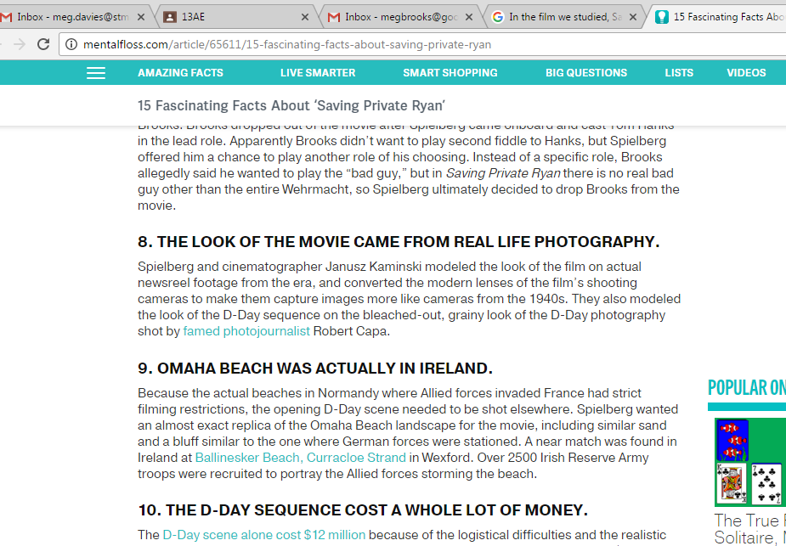

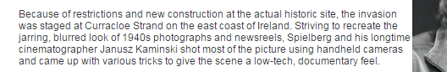

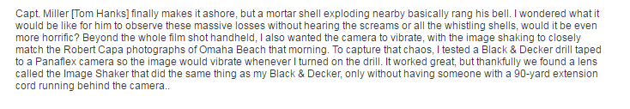

Use this information….
Handheld cameras helped me to understand the realities of war. The footage is shaky and jolty – which likens it to actual real footage; handheld cameras were used to enhance the movie by showing trauma and disorientation of the actors. For example, in the Omaha Beach battle scene, the handheld cameras moved in correlation with the soldiers, with blood splatters hitting the lens for extra effect. As the soldiers moved, the camera did too. Handheld cameras added another dimension to the audience’s viewing of the movie. Because as a watcher, seeing this scene and techniques made me feel involved with the movie too. The audience felt as though you could move along with the soldiers, which made is seem ‘real’ or as though they could relate to it. The footage seemed like it was captured in the original war and as though it was an actual documentary as opposed to a Hollywood production. I think the director used this technique of handheld cameras to show war in a the truest state possible – to pay respects to the soldiers and let the audience catch a glimpse of what the realities of war are. I think it’s important that Spielberg used this technique because teenagers can watch and learn the great devastation that occurred. We have no ideas even how to comprehend the war so this was an eye-opener. I think it’s important for teenagers to gain an appreciation for our past generations, who fought for us to make the world a better place that it is today.

